**AI Assisted Coding-7.3**

|| Batch-09 || 2303A51649

**Task 1: Fixing Syntax Errors**

**Scenario**: You are reviewing a Python program where a basic function definition contains a syntax error.

**Code:**

#Task-01: def add(a,b) return a+b

# Function to add two numbers

# Error: Missing colon (:) at the end of function definition

# Syntax Error - def add(a, b) is missing a colon

# CORRECTED CODE: def add(a, b):

"""Function that takes two parameters and returns their sum""" return a + b

# Test the function result = add(5, 3)

print(f"The sum of 5 and 3 is: {result}") **Output:**

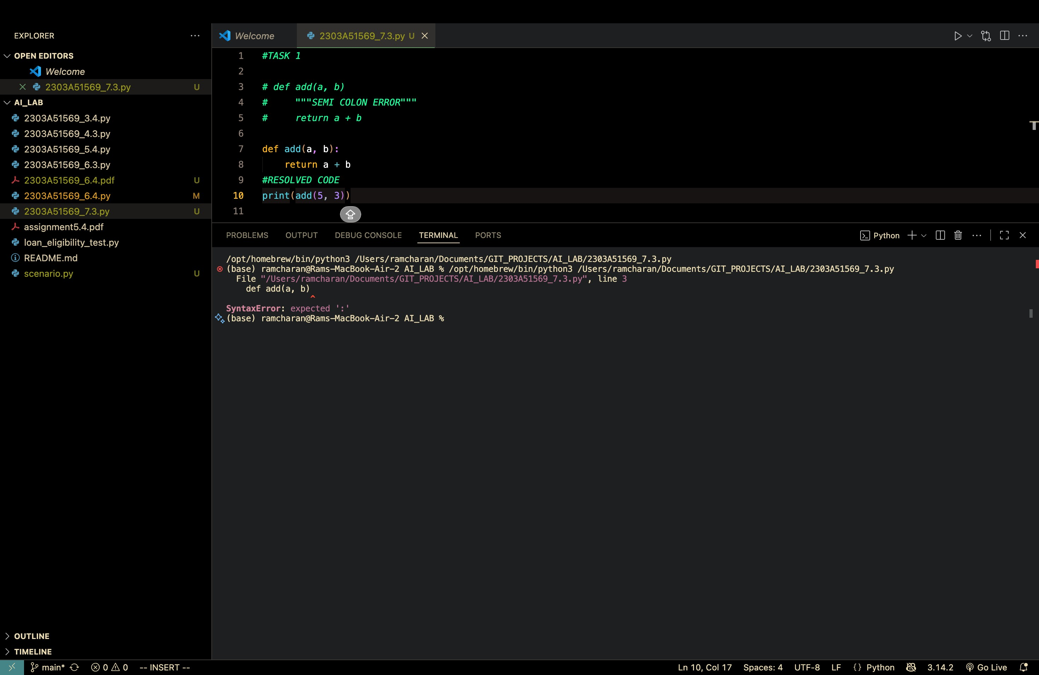

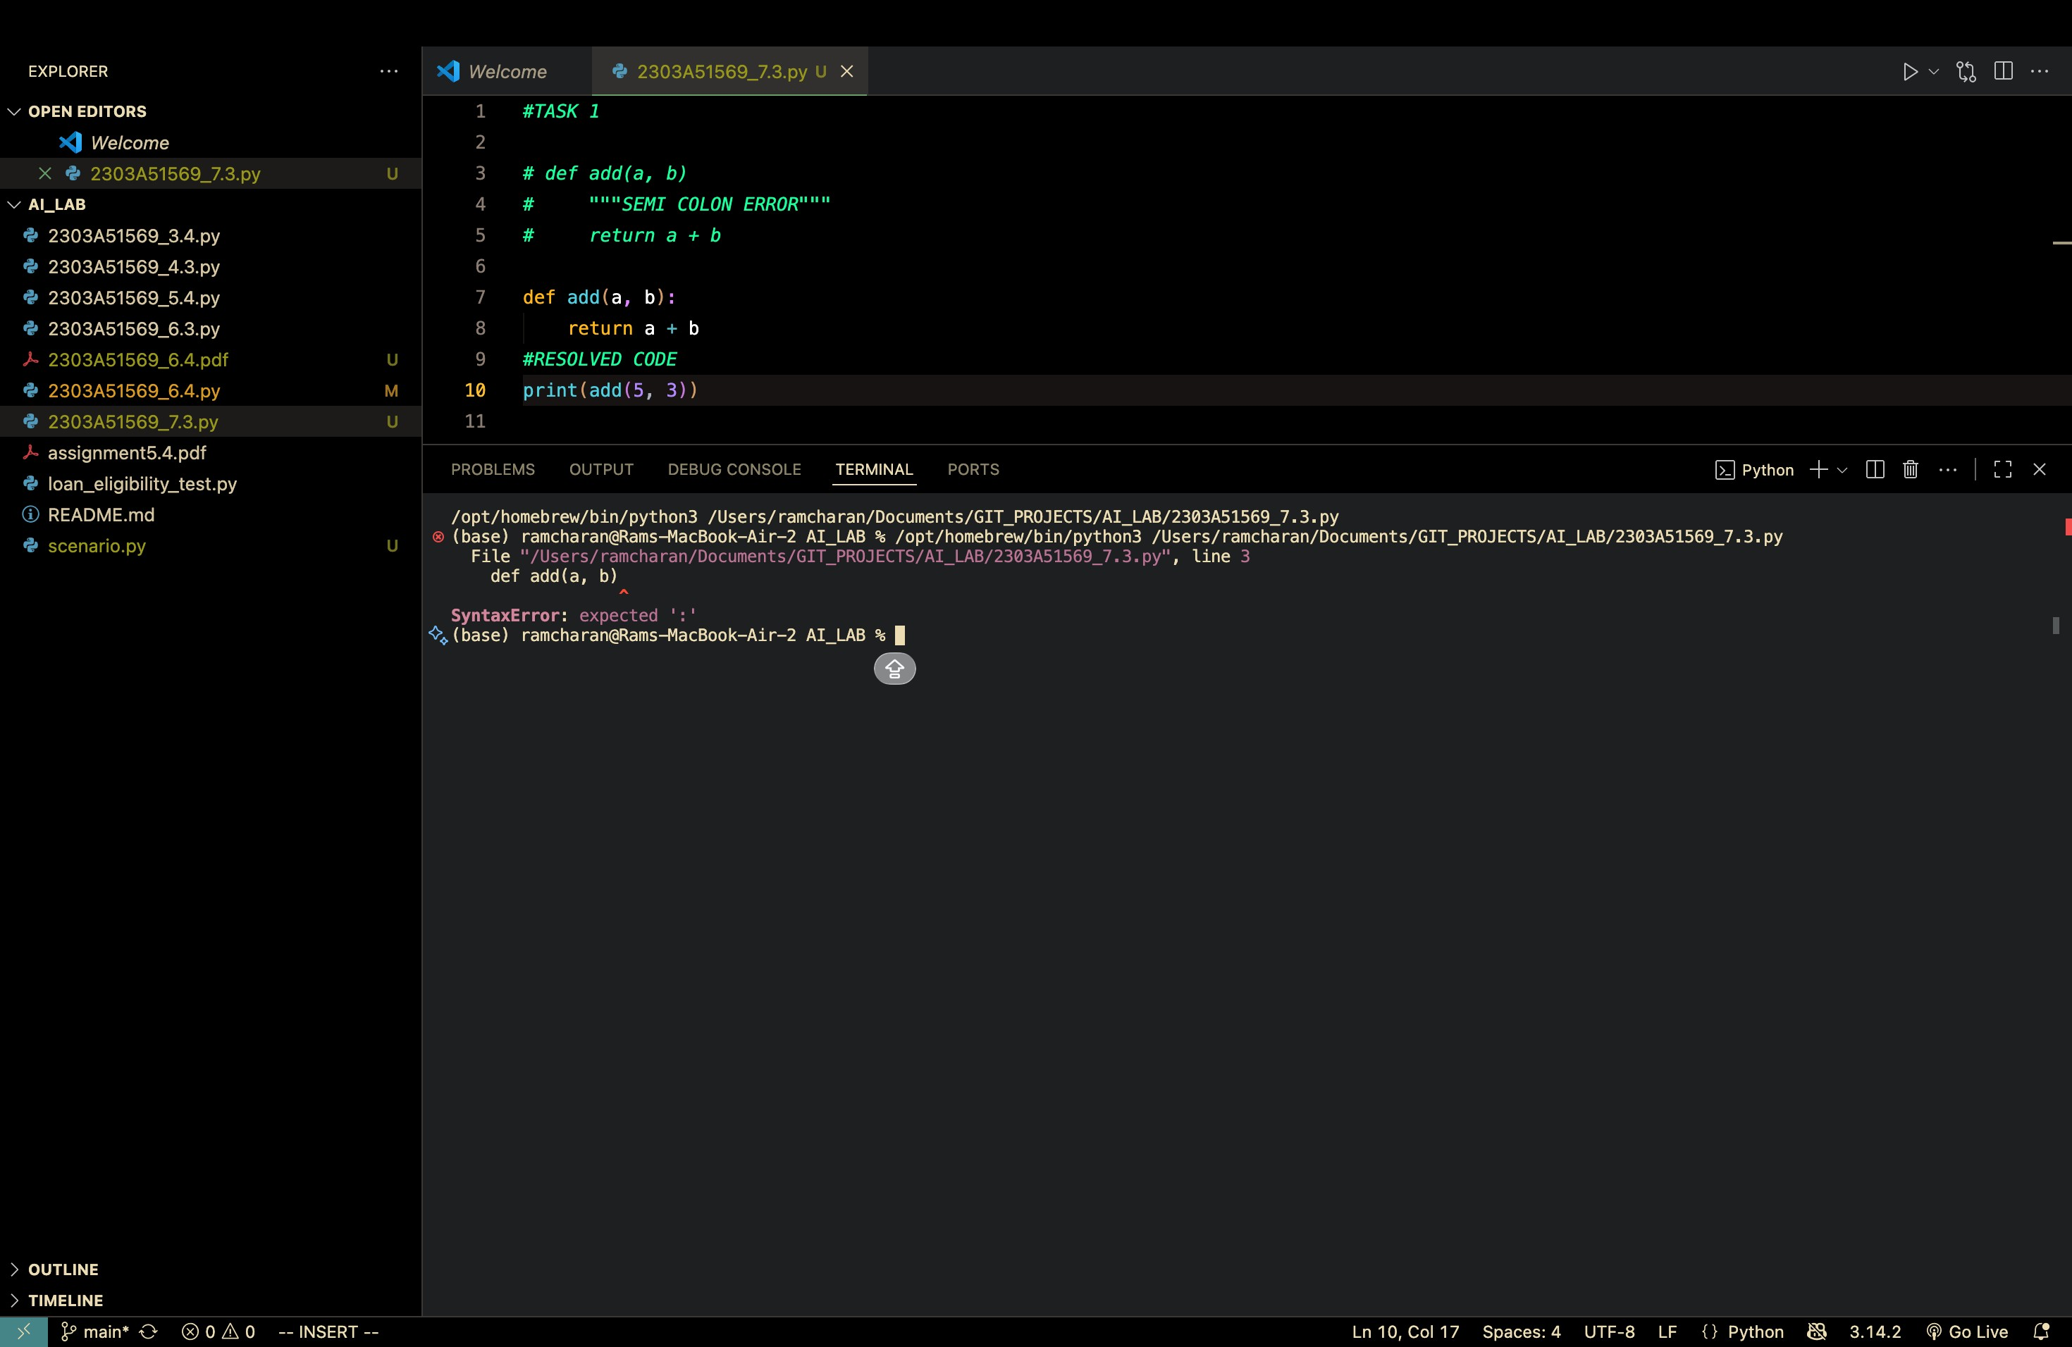

**Task 2: Debugging Logic Errors in Loops**

**Scenario:** You are debugging a loop that runs infinitely due to a logical mistake.

**Code:**

#Task-02:

# Infinite Loop - ERROR VERSION print("ERROR VERSION - Infinite Loop:") i = 0 while i < 5:

print(f"Iteration {i}")

# Problem: i is never incremented, so the loop never exits

# The condition i < 5 is always True

# CORRECTED CODE:

print("\nCORRECTED VERSION:") i = 0 while i < 5:

print(f"Iteration {i}")

i += 1 # Increment i by 1 each iteration to eventually reach the exit condition **Output:**

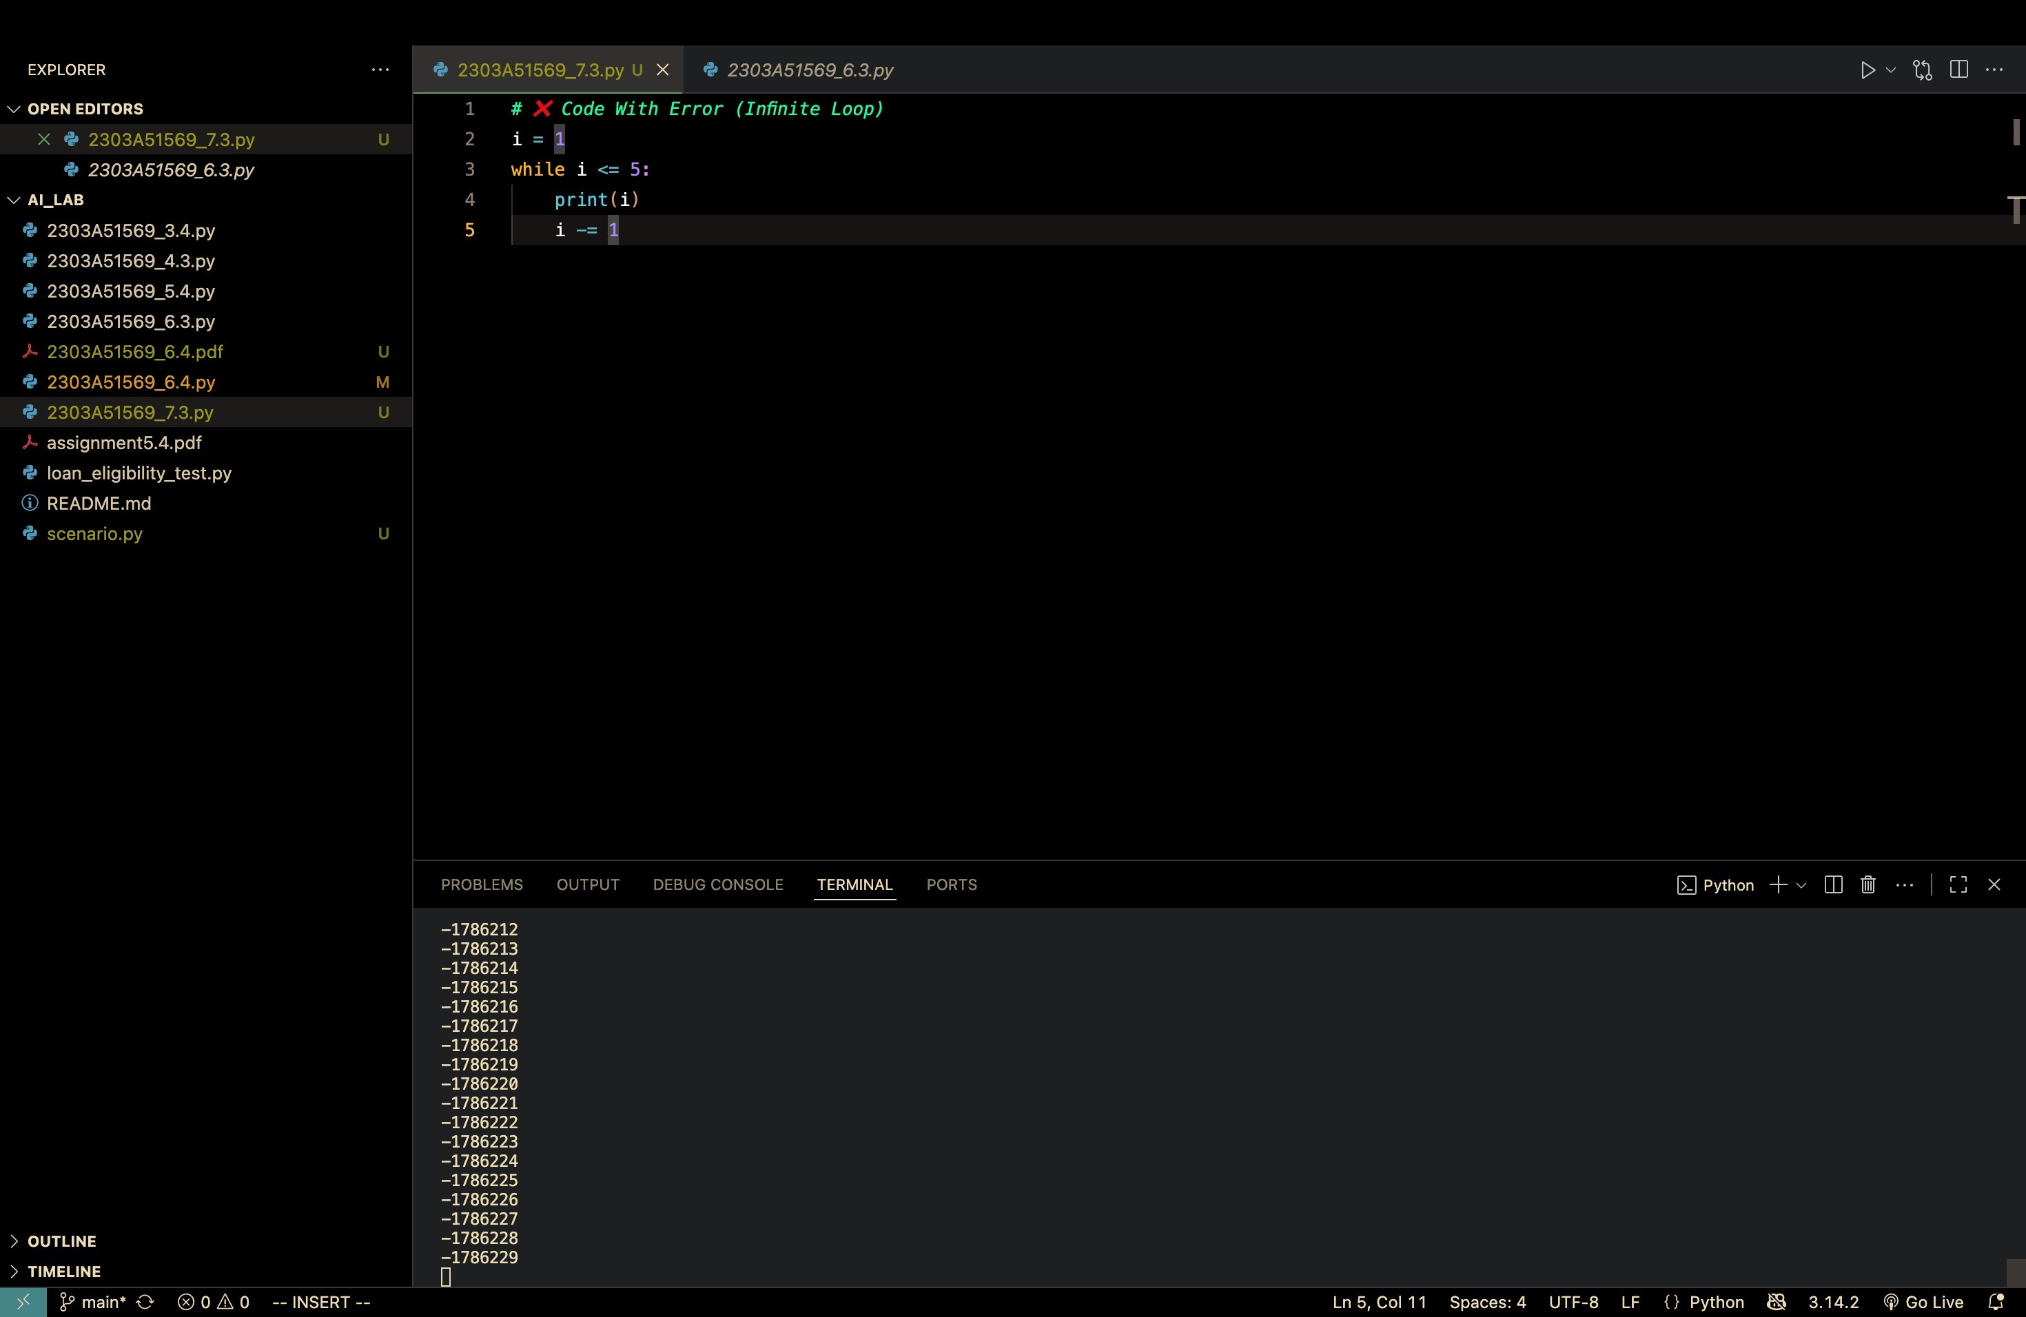

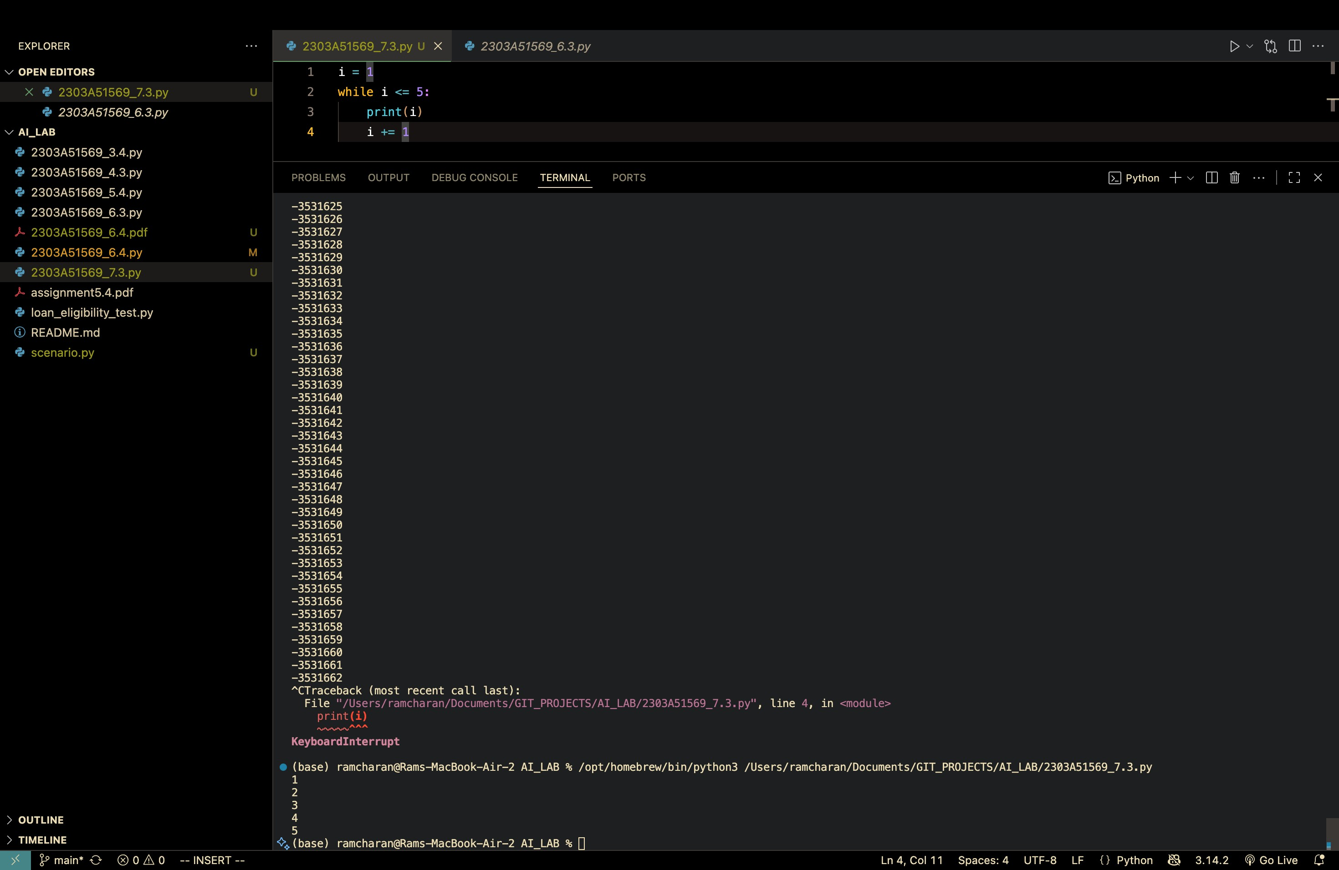

**Task 3: Handling Runtime Errors (Division by Zero) Code:**

#Task 3: Handling Runtime Errors (Division by Zero) # Function WITHOUT validation (causes runtime error) def divide_without_validation(a, b):

"""Division function with no error handling - will crash if b is 0""" return a / b

# Test - this will crash

print("WITHOUT VALIDATION:") try:

result = divide_without_validation(10, 0) print(f"Result: {result}") except ZeroDivisionError: print("ERROR: Cannot divide by zero!")

# Function WITH try-except blocks (safe execution) def divide_with_validation(a, b):

"""Division function with error handling using try-except""" try:

# Attempt the division operation result = a / b return result except ZeroDivisionError: # Catch division by zero error print("Error: Cannot divide by zero. Denominator must be non-zero.") return None except TypeError:

# Catch type errors (non-numeric values) print("Error: Both arguments must be numbers.") return None

# Test - safe execution print("\nWITH VALIDATION:") result = divide_with_validation(10, 2) if result is not None: print(f"Result: {result}") result = divide_with_validation(10, 0) **Output:**

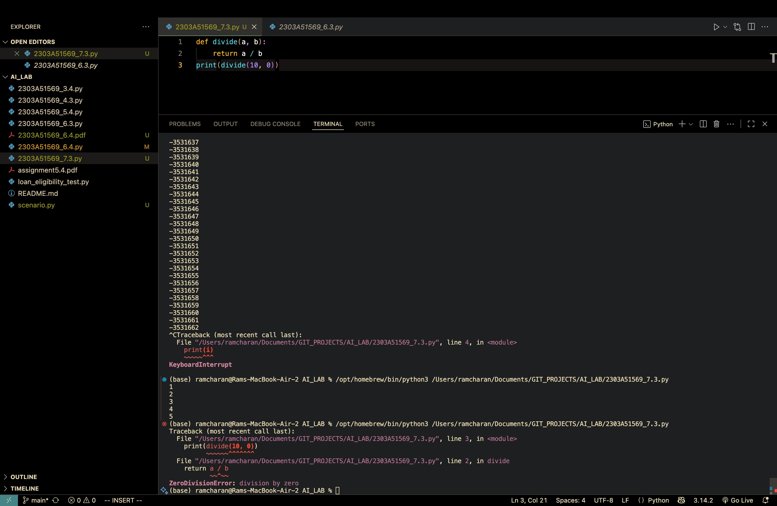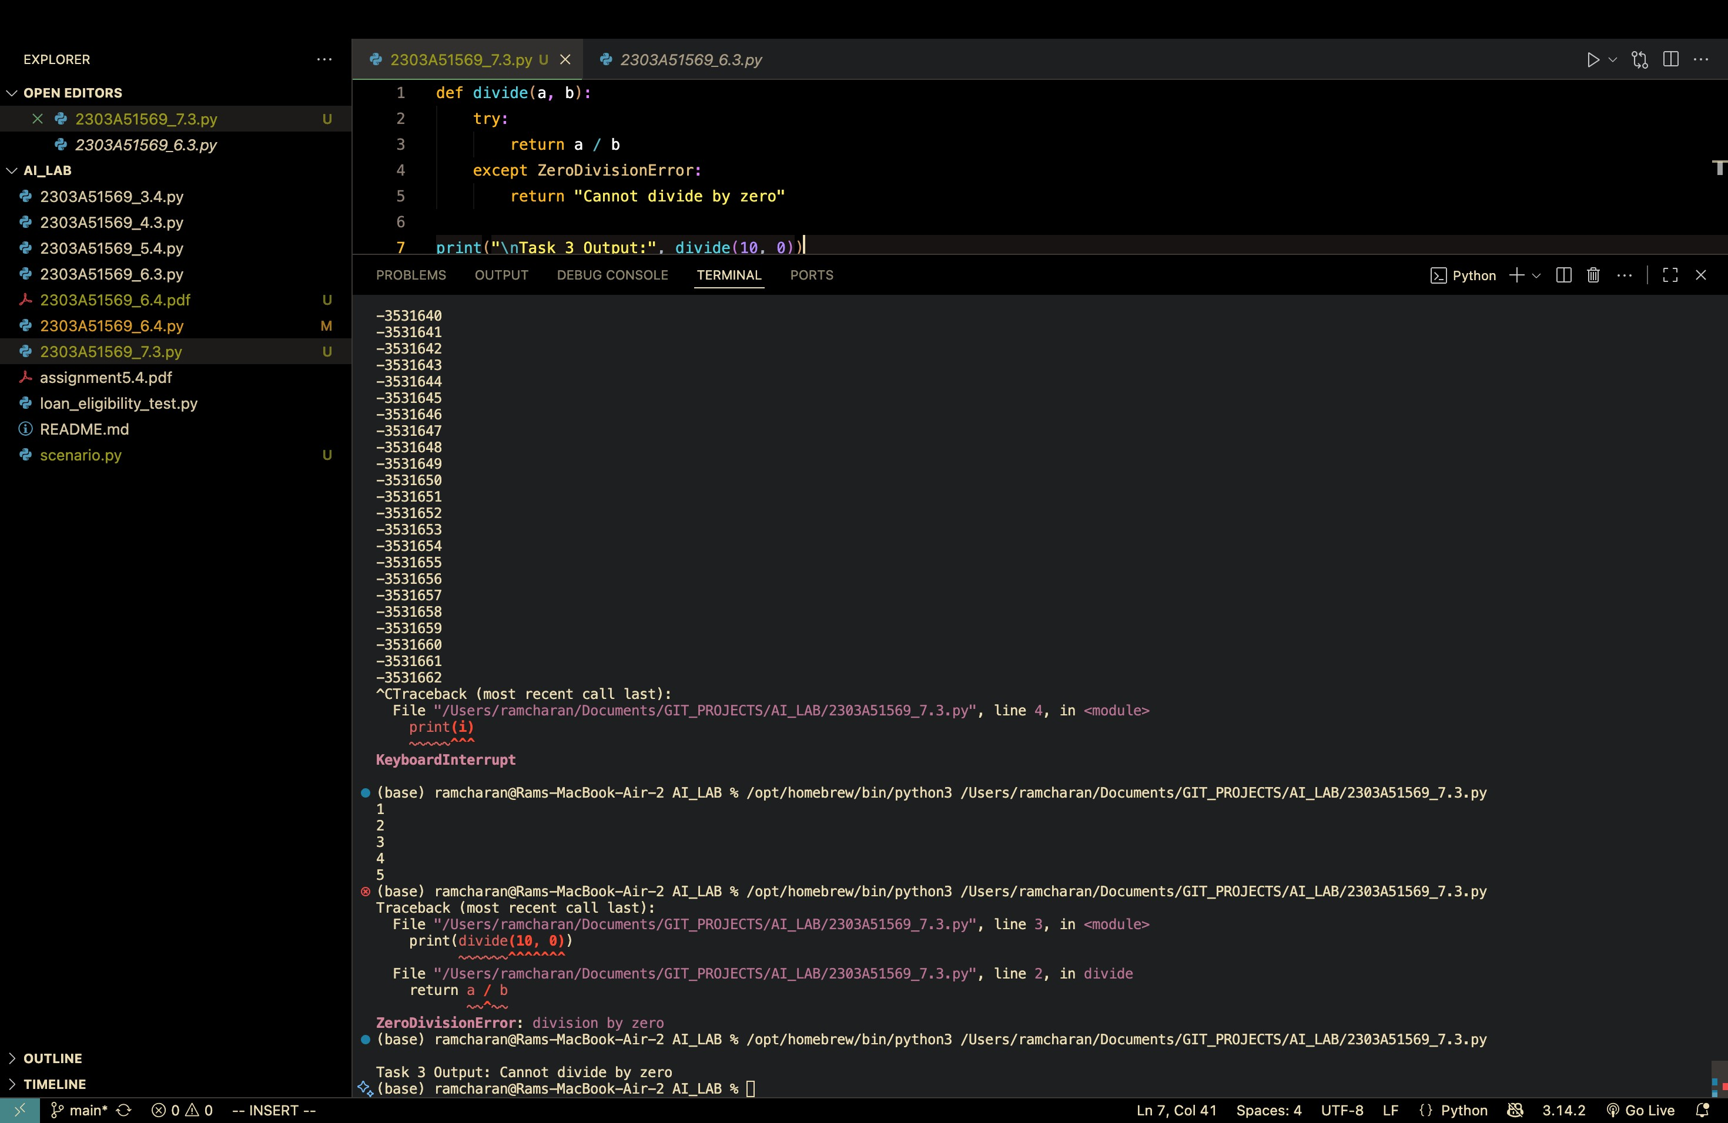

**Task 4: Debugging Class Definition Errors Code:**

#Task 4: Debugging Class Definition Errors

# FAULTY CODE - Missing 'self' parameter in __init__()

print("\nFAULTY CLASS DEFINITION:") class Person:

"""Class definition with ERROR in constructor""" def __init__(name, age): # ERROR: Missing 'self' as first parameter """Constructor without self parameter - causes TypeError""" name = name age = age

# This will cause an error when trying to create an instance

# TypeError: __init__() takes 2 positional arguments but 3 were given # try:

# person1 = Person("Alice", 30) # except TypeError as e:

# print(f"ERROR: {e}")

# CORRECTED CODE - Proper class definition with 'self' parameter

print("\nCORRECTED CLASS DEFINITION:") class Person:

"""Class definition with proper constructor including 'self' parameter""" def __init__(self, name, age):

"""Constructor with 'self' parameter - allows proper object creation self: represents the instance of the class name: parameter for person's name age: parameter for person's age""" self.name = name # Store name as instance variable self.age = age # Store age as instance variable

def display_info(self):

"""Method to display person's information""" print(f"Name: {self.name}, Age: {self.age}")

# Test - safe execution with corrected class try:

person1 = Person("Alice", 30)

person1.display_info()

person2 = Person("Bob", 25) person2.display_info() except TypeError as e: print(f"ERROR: {e}") **Output:**

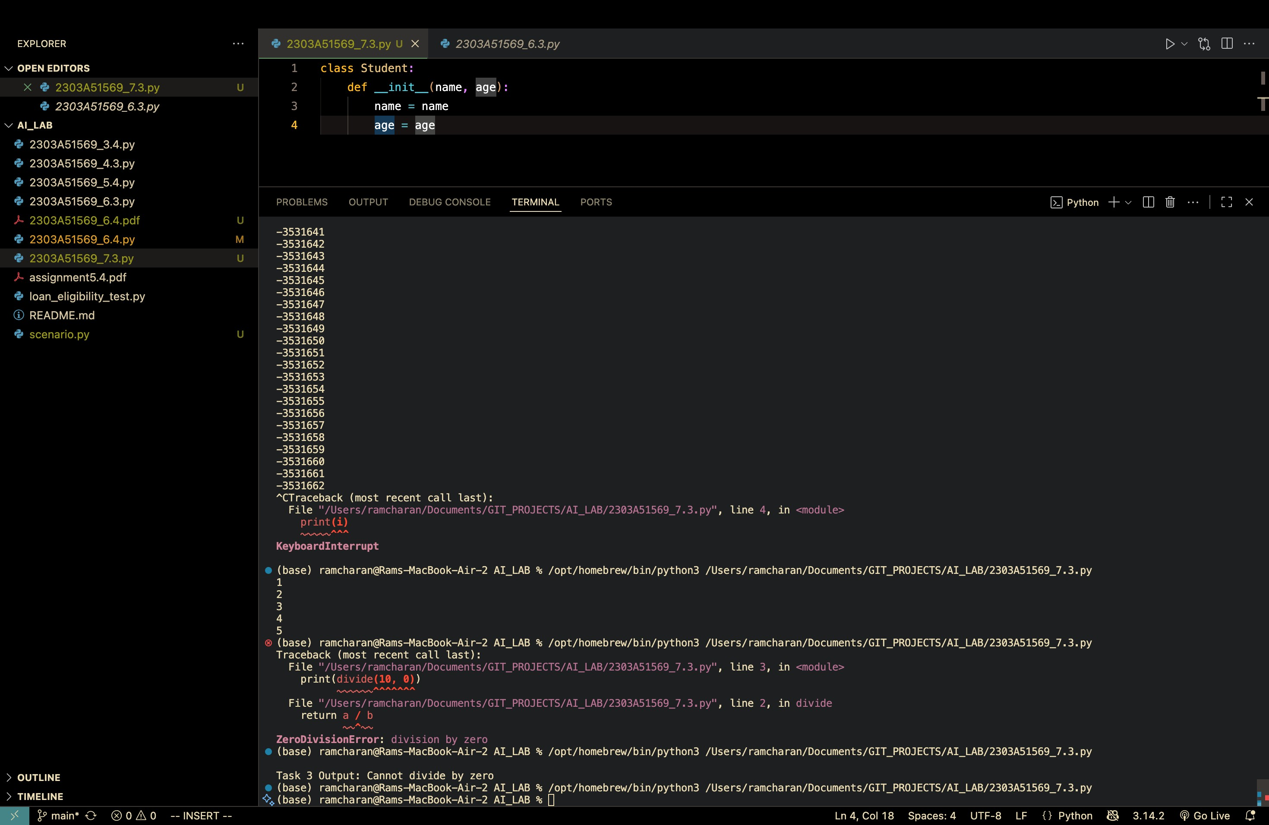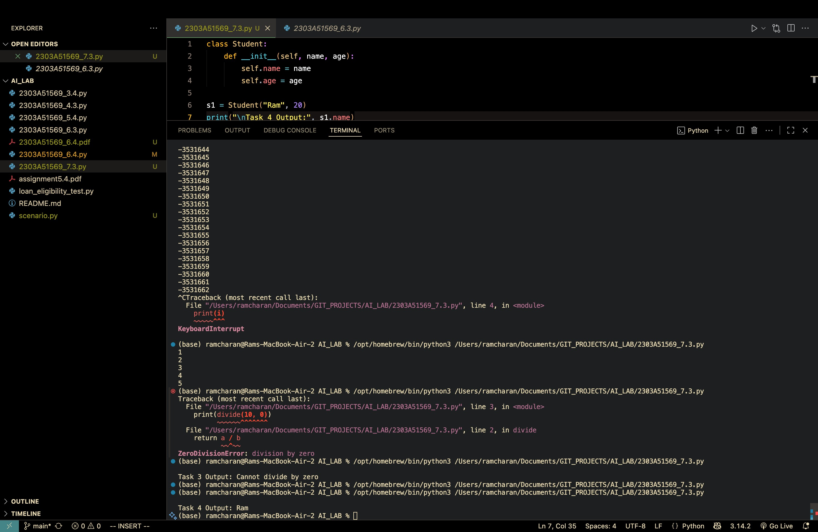

**Task 5: Resolving Index Errors in Lists**

**Code:**

#Task-05: Handling Index Errors (Out-of-Range List Access)

# Function WITHOUT validation (causes runtime error) def access_list_without_validation(lst, index):

"""Function that accesses list without bounds checking - will crash if index is out of range""" return lst[index]

# Test - this will crash

print("WITHOUT VALIDATION:") try:

my_list = [10, 20, 30, 40, 50] result = access_list_without_validation(my_list, 10) # Index 10 doesn't exist (list has only 5 elements) print(f"Value at index 10: {result}") except IndexError: print("ERROR: List index out of range!")

# Function WITH try-except blocks (safe execution) def access_list_with_validation(lst, index):

"""Function that accesses list with error handling using try-except""" try:

# Attempt to access the list at given index result = lst[index] return result except IndexError:

# Catch index out of range error print(f"Error: Index {index} is out of range. List has only {len(lst)} elements.") return None except TypeError:

# Catch type errors (non-numeric index) print("Error: Index must be an integer.") return None

# Test - safe execution print("\nWITH VALIDATION:") my_list = [10, 20, 30, 40, 50]

result = access_list_with_validation(my_list, 2) if result is not None: print(f"Value at index 2: {result}")

result = access_list_with_validation(my_list, 10) **Output:**

